Lab Objective

Implementing the Application Servers

**Lab Procedures**

**1.** On Server01, continuing with the Remote Access Setup Configuration page, under Step 4, Application Servers, click Configure. The DirectAccess Application Server Setup Wizard starts.

**2.** On the DirectAccess Application Server Setup page, click Finish, accepting the default option selected – Do not extend authentication.

**3.** At the bottom of the Remote Access Management console, click Finish to apply all the changes for Steps 1 through 4.

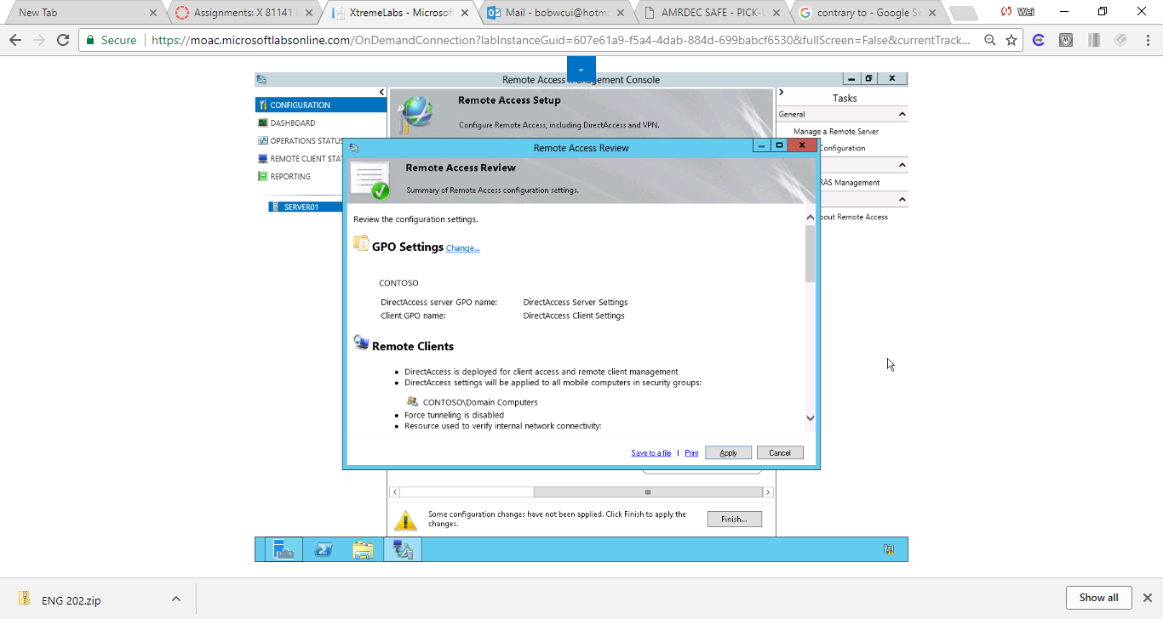

Figure 1 At the bottom of the Remote Access Management console, click Finish to apply all the changes for Steps 1 through 4

**4.** Take a screen shot of the Remote Access Management Console window by pressing Alt+Prt Scr and then paste it into your Lab011_worksheet file in the page provided by pressing Ctrl+V.

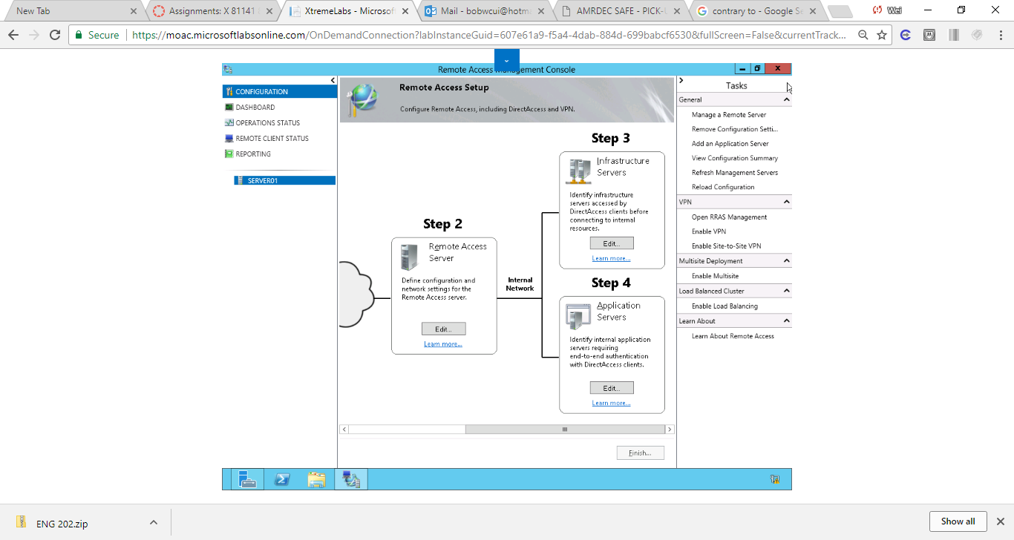

Figure 2 At the bottom of the Remote Access Management console, applied all the changes for Steps 1 through 4

**5.** When the Remote Access Review dialog box opens, click Apply.

**6.** When the settings have been applied, click Close. Close the Remote Access Management Console.

**Lab Summary**

Lastly, during Step 4 of the Remote Access Setup Wizard, I have configured any application servers and apply all the changes that I have configured for Steps 1 through 4. When configurating DirectAccess, finish to apply all the changes for Steps 1 through 4 at the bottom of the Remote Access Management console.